Chapter 11, Problem 7.

Given the circuit of Fig. 11.40, find the average power absorbed by the 10-Ω resistor.

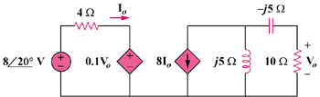

Figure 11.40
For Prob. 11.7.

